*The Procurement Technical Assistance Center (PTAC) of Wayne State University present*s:

2022 – 2023 Government Contracting Virtual Training Sessions

*If your small business is considering the field of government contracting, we have the course for you!*

All sessions are virtual via zoom from your personal device. All are **FREE**, but registration is required one week in advance. Seating is limited, so please register early. Links for sessions will be sent out only to those who register.

**Meet the SBA – How to Become a Federal Small Business Contractor**

* September 21, 2022 9 am – 10 am
* February 15, 2023 9 am – 10 am

**Government Contracting 101: System for Award Management (SAM.gov)**

* August 3, 2022 9 am – 10 am
* February 1, 2023 9 am - 10 am

**Meet the SBA – Small Business Administration (WOSB Program)**

* October 19, 2022 9 am – 10 am
* March 15, 2023 9 am – 10 am

**Government Contracting 101: Small Business Administration Programs (SBA)**

* September 7, 2022 9 am – 10 am
* March 1, 2023 9 am – 10 am

**Government Contracting 101: Finding Opportunities**

* October 5, 2022 9 am – 10 am
* April 26, 2023 9 am – 10 am

**Government Contracting 101: Proposal Writing and Bidding**

* November 2, 2022 9 am – 10 am
* May 24, 2023 9 am – 10 am

**Government Contracting 101: Marketing to the Government**

* December 7, 2022 9 am – 10 am
* June 21, 2023 9 am – 10 am

**Market Research: Unlocking the Keys to Competitive Bidding Part I**

* November 16, 2022 9 am – 10 am
* January 11, 2023 9 am – 10 am

**Market Research: Unlocking the Keys to Competitive Bidding Part II**

* December 14, 2022 9 am – 10 am
* January 25, 2023 9 am – 10 am

**Proposal Writing and Bid Package Basics**

* August 17, 2022 9 am – 10 am
* June 7, 2023 9 am – 10 am

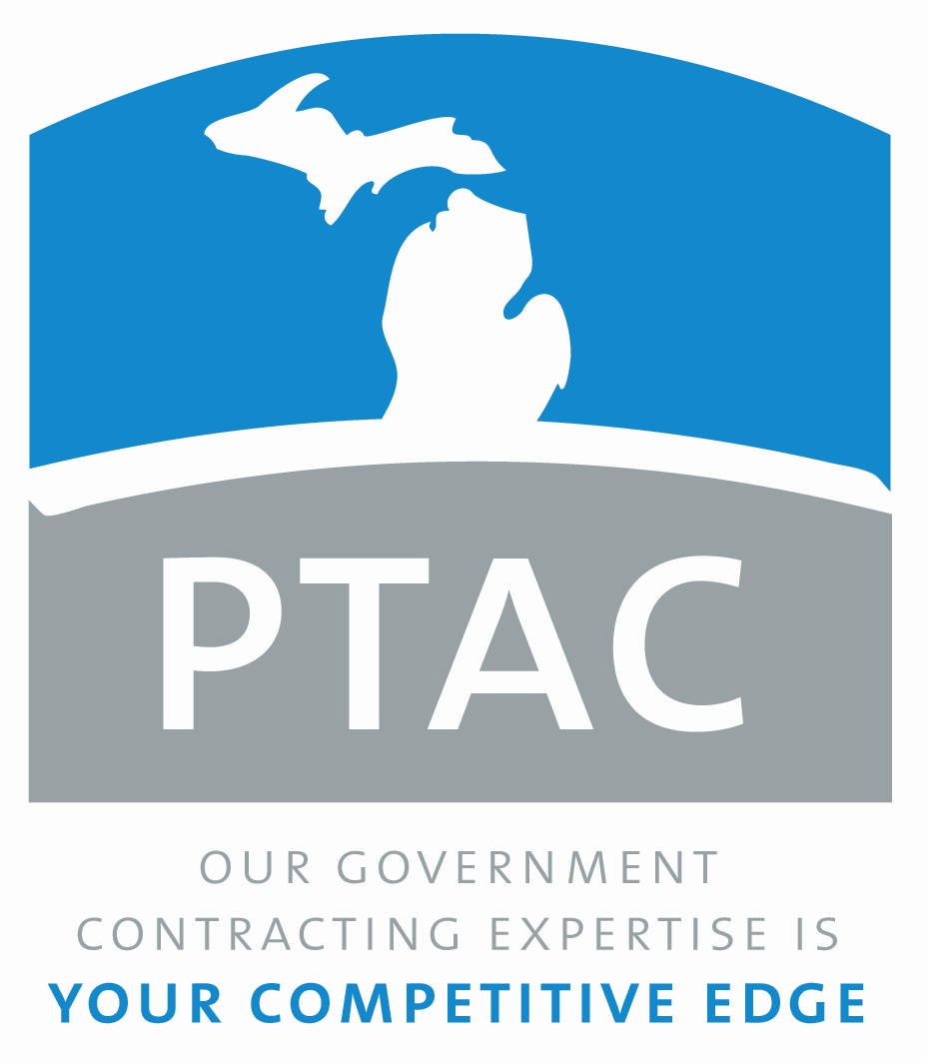**REGISTRATION IS REQUIRED**

Contact the Wayne State PTAC at [ptac@wayne.edu](mailto:ptac@wayne.edu) to register.

This Procurement Technical Assistance Center (PTAC) is funded in part through a cooperative agreement with the Department of Defense. Additionally, the PTAC is funded by the Michigan Economic Development Corporation (MEDC).